**Lab#10(a) Setup a Laravel project for book inventory**

|  |  |  |
| --- | --- | --- |
| **COMMAND USED** | **ATTRIBUTES USED** | **DESCRIPTION** |
| Artisan | make:controller, make:model, make:migration, serve | In Laravel, Artisan is a command-line tool that provides a wide range of commands for various tasks related to the development and management of Laravel applications. Artisan simplifies common development tasks by automating them through command-line commands. |

For creating a Laravel Project for book inventory management create a folder for the project and open terminal and type command “larvae new book_inventory”.

**Final Outcome:**

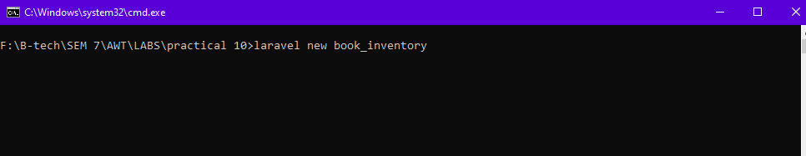

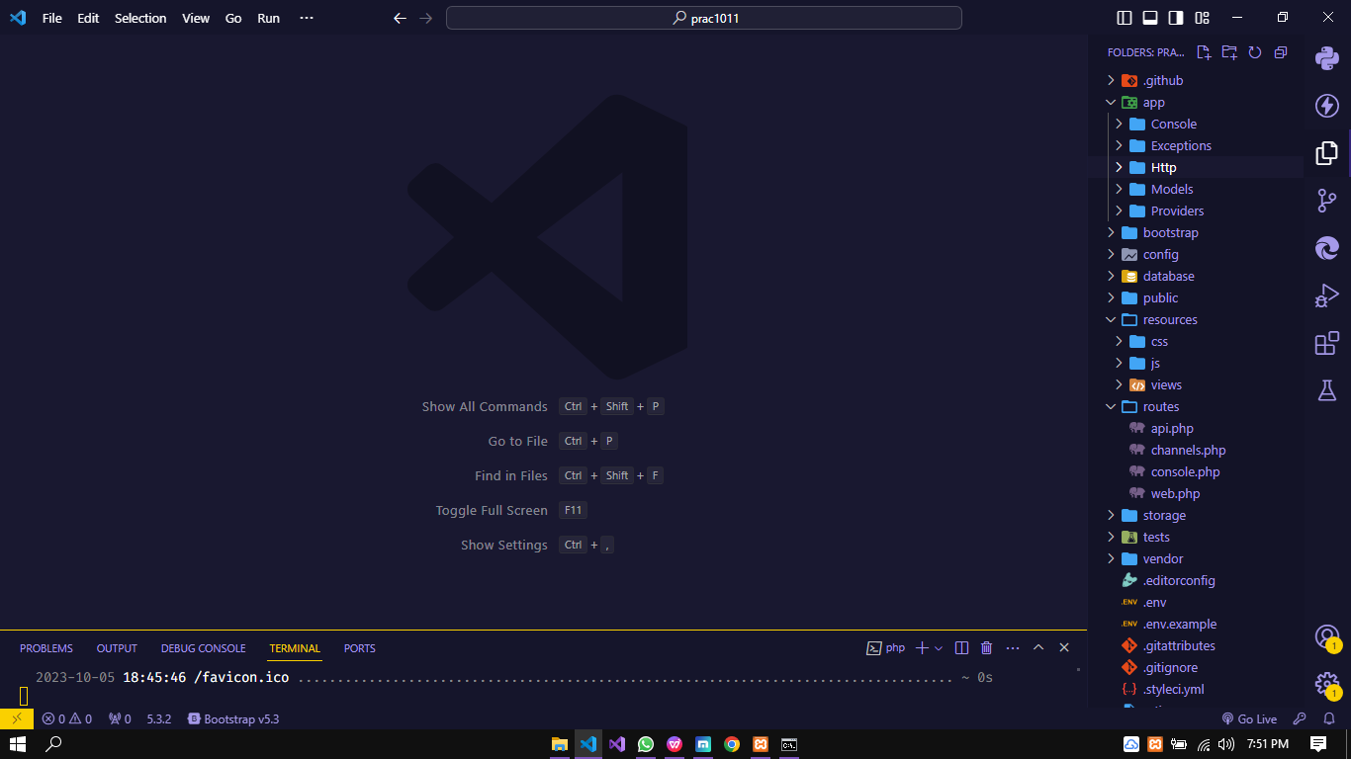

**Code Snippet:**

For creating a Laravel Project for book inventory management create a folder for the project and open terminal and type command “larvae new book_inventory”.

**b. Setup the database in Laravel.**

Change this values in .env file

**Final Outcome:**

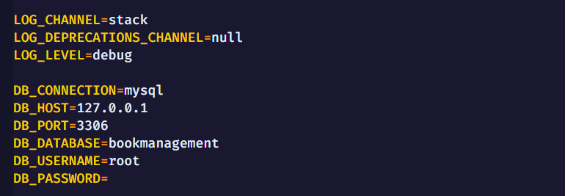

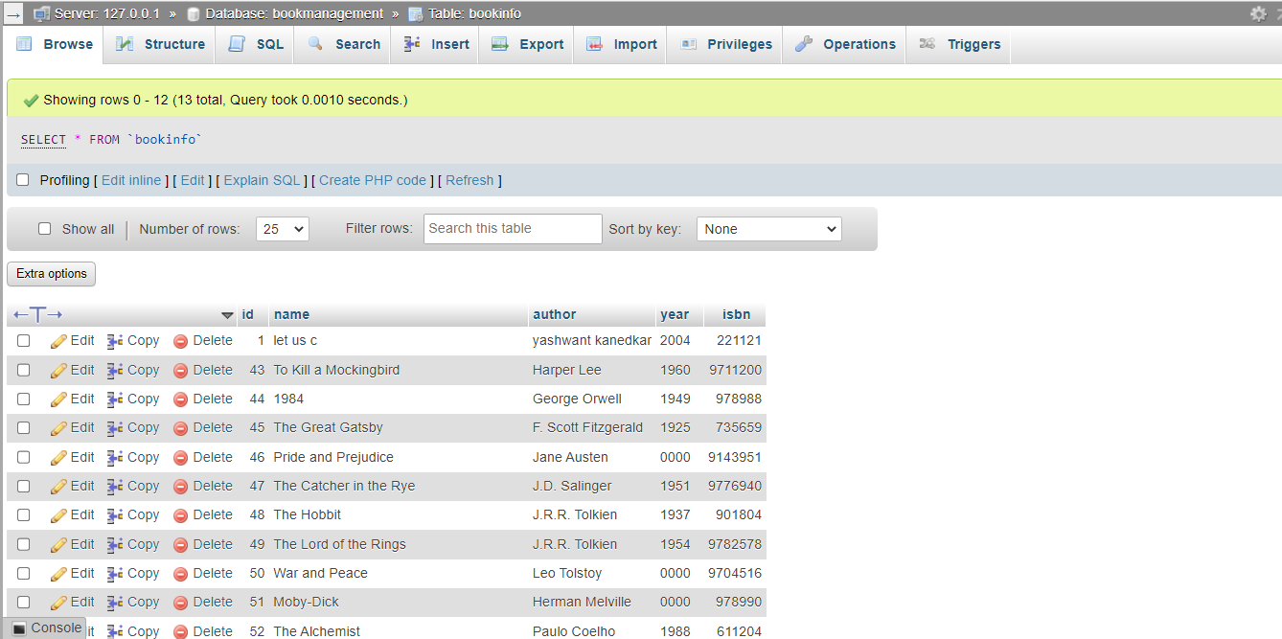

**c. Implement Select Operation in Laravel with GUI**

**Final Outcome:**

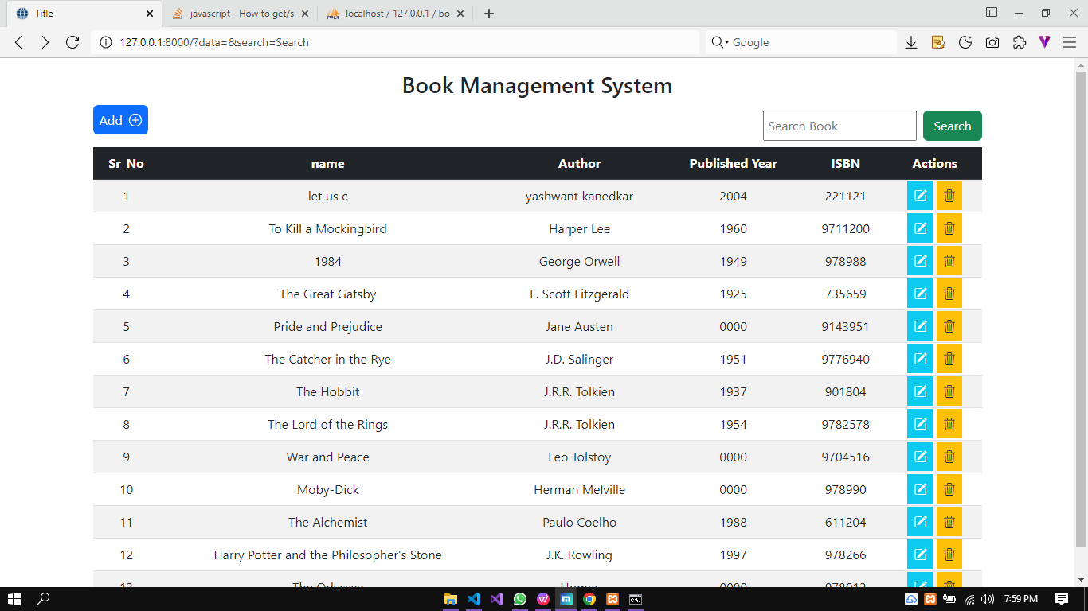

**Code snippet:**

<!doctype html>

<html lang="en"

<head>

<title>Title</title>

<!-- Required meta tags -->

<meta charset="utf-8">

<meta name="viewport" content="width=device-width, initial-scale=1, shrink-to-fit=no">

<link rel="stylesheet" href="https://cdnjs.cloudflare.com/ajax/libs/bootstrap-icons/1.11.1/font/bootstrap-icons.min.css" integrity="sha512-oAvZuuYVzkcTc2dH5z1ZJup5OmSQ000qlfRvuoTTiyTBjwX1faoyearj8KdMq0LgsBTHMrRuMek7s+CxF8yE+w==" crossorigin="anonymous" referrerpolicy="no-referrer" />

<!-- Bootstrap CSS v5.2.1 -->

<link href="https://cdn.jsdelivr.net/npm/bootstrap@5.2.1/dist/css/bootstrap.min.css" rel="stylesheet"

integrity="sha384-iYQeCzEYFbKjA/T2uDLTpkwGzCiq6soy8tYaI1GyVh/UjpbCx/TYkiZhlZB6+fzT" crossorigin="anonymous"

</head>

<body>

<header>

<!-- place navbar here -->

</header>

<main>

</main>

<footer>

<!-- place footer here -->

</footer>

<!-- Bootstrap JavaScript Libraries -->

<script src="https://cdn.jsdelivr.net/npm/@popperjs/core@2.11.6/dist/umd/popper.min.js"

integrity="sha384-oBqDVmMz9ATKxIep9tiCxS/Z9fNfEXiDAYTujMAeBAsjFuCZSmKbSSUnQlmh/jp3" crossorigin="anonymous">

</script>

<script src="https://cdn.jsdelivr.net/npm/bootstrap@5.2.1/dist/js/bootstrap.min.js"

integrity="sha384-7VPbUDkoPSGFnVtYi0QogXtr74QeVeeIs99Qfg5YCF+TidwNdjvaKZX19NZ/e6oz" crossorigin="anonymous">

</script>

<h1 class="fs-3 text-center my-3">Book Management System</h1>

<div class="container ">

<div class="content d-flex mb-2 justify-content-between ">

<div class="addbtn">

<a class="bg-primary rounded text-white p-2 my-1 text-decoration-none " href="/add">Add<i class="ms-2 bi bi-plus-circle"></i></a>

</div>

<div class="searchbox">

<form method="get" class="d-flex justify-content-center gap-2" action="">

<input type="text" class="p-1" name="data" placeholder="Search Book">

<input class="btn btn-success" name="search" type="submit" value="Search">

</form>

</div>

</div>

<table class="table table-striped caption-top table-hover table-responsive ">

<thead class="text-center table-dark">

<tr>

<th scope="col">Sr_No</th>

<th scope="col">

name

</th>

<th scope="col">

Author

</th>

<th scope="col">

Published Year

</th>

<th scope="col">

ISBN

</th>

<th scope="col">Actions</th>

</tr>

</thead>

<tbody class="text-center">

@php

$count=1;

@endphp

@foreach ($r as $book)

<tr scope="row">

<td>{{$count}}</td>

<td>{{$book->name}}</td>

<td>{{$book->author}}</td>

<td>{{$book->year}}</td>

<td>{{$book->isbn}}</td>

@php

$count++;

@endphp

<td>

<a id="" class="text-white bg-info p-2" href="{{route('book.edit',['id'=>$book->id])}}"><i class="bi bi-pencil-square"></i></a>

<a id="delbtn" href="{{route('book.delete',['id'=>$book->id])}}" class="text-dark bg-warning p-2" > <i class="bi bi-trash3"></i></a>

</td>

</tr>

@endforeach

</tbody>

</table>

</div>

</body>

</html>